**POWER QUALITY ANALYSIS**

PROJECT REPORT

***Submitted by***

BL.EN. U4EEE21003 AKASH SHENOY

BL.EN. U4EEE21020 MYREDDY KUMAR DURGA TRINADH

BL.EN. U4EEE21029 SATYAM SHARMA



AMRITA SCHOOL OF ENGINEERING, BANGALORE

AMRITA VISHWA VIDYAPEETHAM

FEB 2023- JUL 2023

**Amrita School of Engineering, Bengaluru – 560035**



*This is to certify that the project report entitled “POWER QUALITY ANALYSIS” submitted by,*

*BL.EN. U4EEE21003 AKASH SHENOY*

*BL.EN. U4EEE21020 MYREDDY KUMAR DURGA TRINADH*

*BL.EN. U4EEE21029 SATYAM SHARMA*

*In 2nd year of Degree-Bachelor of Technology in “Electrical and Electronics Engineering” is a bonafide record of the work carried out under our guidance and supervision at Amrita Vishwa Vidyapeetham for the* ***FOURTH*** *Semester B. Tech during the academic year* **February 2023 - July 2023***.*

***Faculty In charge***

**ABSTRACT:**

The voltage and current quality are one of the main challenges faced by the industrial consumers as well as distributors. The analysis of power quality is analyzed when a non-linear load is connected across a three-phase source. We are calculating or obtaining voltage and current graphs and its values, power factor, apparent power, real power, total power and THD (Total Harmonic Distortion in %). We are proving the THD% of Voltage is <5% and THD% of Current is <20%. We are doing it in hardware and showing the output in arduino IDE or LCD.

**Objective of the Project:**

* The objective of power system analysis with a load is to analyze the Voltage and current waveforms, to calculate all the power parameters along with power factor and finding THD of current signal
* Total Harmonic Distortion is the typical measurement made with handheld

harmonic analyzing equipment which takes a snapshot of the system power

quality.

* Voltage THD should not exceed 5%, and the current THD should not exceed 20% of the fundamental frequency
* Non-linear loads can cause distortion in the current waveform, leading to a low power factor and a high current flow that can overload the system.

**Aim of the Project:**

To display the Voltage and Current readings and plot the graph drawn from the AC supply and analyze it by displaying real power, apparent power, reactive power and power factor along with total harmonic distortion value of voltage and current.

**Components required:**

ZMPT101B Voltage Sensor, SCT-013-030 Non-Invasive AC Current Sensor, Arduino UNO Microcontroller, Plug Socket, Breadboard, Resistors(10kΩ,47Ω), Capacitor-10µF and Load (applicable non-linear).

**Block Diagram:**

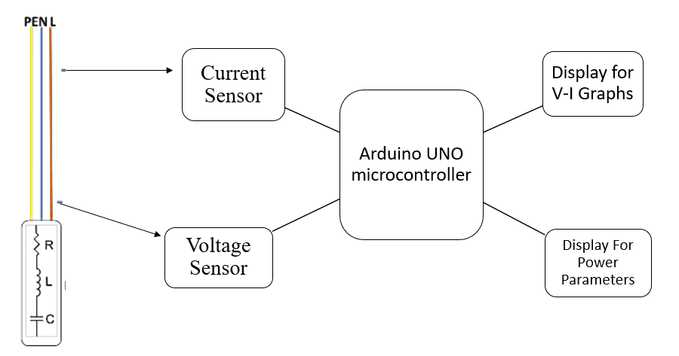

**CODE:**

(For Voltage Measurement and graph)

double sensorValue1 = 0;

int Val [100];

int max_v = 0;

int f=50;

int fs=1000;

double VmaxD = 0;

double VeffD = 0;

double Veff = 0;

float t [41];

float v1[41], v3[41], v5[41], v7[41];

float v [41];

float TH = 0.0;

float THD = 0.0;

void setup() {

  Serial. Begin (9600);

 // Calculate the time vector

  for (int i = 0; i <= 40; i++) {

    t[i] = (float)i / fs;

  }

}

void loop() {

  for (int i = 0; i < 100; i++) {

    sensorValue1 = analogRead(A0);

    if (analogRead(A0) > 511) {

      val[i] = sensorValue1;

    }

    else {

      val[i] = 0;

    }

    delay (1);

  }

  for (int i = 0; i < 100; i++)

  {

    if (val[i] > max_v)

    {

      max_v = val[i];

    }

    val[i] = 0;

  }

  if (max_v != 0) {

    VmaxD = max_v;

    VeffD = VmaxD / sqrt (2);

    Veff = (((VeffD - 420.76) / -90.24) * -210.2) + 210.2-75.06;

  }

  else {

    Veff = 0;

  }

  Serial.println("Voltage: ");

  Serial. Print (Veff);

  Serial.println(Veff);

  VmaxD = 0;

   // Calculate v1, v3, v5, v7, and v

  for (int i = 0; i <= 40; i++)

   {

    v1[i] = Veff * sin (2 * PI * f * t[i]);

    v3[i] = Veff / 3.0 * sin(2 * PI * 3 * f * t[i]);

    v5[i] = Veff / 5.0 * sin (2 * PI * 5 * f * t[i]);

    v7[i] = Veff / 7.0 * sin (2 * PI * 7 * f * t[i]);

    v[i] = v1[i] + v3[i] + v5[i] + v7[i];

  }

   // Print the v values to the Serial Monitor

  for (int i = 0; i <= 40; i++) {

   //Serial.println(v[i]);

  }

for (int i = 0; i <= 40; i++)

   {

     TH = sqrt((v1[i]*v1[i]+v3[i]*v3[i]+v5[i]*v5[i]+v7[i]*v7[i])/v1[i]*v1[i]);

     THD = 100*TH;

  }

  Serial. Print ("THD of Voltage in %");

  Serial.println(THD);

delay (1000);}

(For Current Measurement and graph)

#include "EmonLib.h"

int f=50;

int fs=1000;

float t [41];

float i1[41], i3[41], i5[41], i7[41];

float I [41];

float TH = 0.0;

float THD = 0.0;

Energy Monitor emon1;

//const int Current_signal = A0;

//const int plotInterval = 10;

void setup () {

  Serial.begin(9600);

  //Serial.begin(115200);

emon1.current(1, 30);

  for (int i = 0; i <= 40; i++)

  {

    t[i] = (float)i / fs;

  }

  }

void loop ()

{

  double Irms = emon1.calcIrms(1480); // Calculate Irms only

   Serial.println("Current:");

  Serial.println(Irms);         // Irms

   // Calculate i1, i3, i5, i7, and I

  for (int i = 0; i <= 40; i++)

   {

    i1[i] = Irms * sin (2 * PI * f * t[i]+PI/4);

    i3[i] = Irms / 3.0 * sin (2 * PI * 3 * f * t[i]+PI/4);

    i5[i] = Irms / 5.0 * sin (2 * PI * 5 * f * t[i]+PI/4);

    i7[i] = Irms / 7.0 * sin (2 * PI * 7 * f * t[i]+PI/4);

    I[i] = i1[i] + i3[i] + i5[i] + i7[i];

  }

   // Print the v values to the Serial Monitor

  for (int i = 0; i <= 40; i++) {

   Serial.println(I[i]);

  }

for (int i = 0; i <= 40; i++)

   {

     TH = sqrt((i1[i]*i1[i]+i3[i]*i3[i]+i5[i]*i5[i]+i7[i]*i7[i])/i1[i]*i1[i]);

     THD = 100*TH;

  }

  Serial.print("THD of Current in %");

  Serial.println(THD);

//int sensor Value = analogRead (Current_signal);

  //Serial.print(sensor Value);

  //Serial.print(','); // Separate values with a comma for SerialPlot

  //Serial.println();

 // delay(plotInterval);

delay (1000);

}

(For Power Parameters Measurement)

#include "EmonLib.h"

#include <Arduino>

#include <math>

// Include Emon Library

Energy Monitor emon1;

double sensorValue1 = 0;

double sensorValue2 = 0;

int cross count = 0;

int climb_flag = 0;

int val [100];

int max_v = 0;

double VmaxD = 0;

double VeffD = 0;

double Veff = 0;

int f=50;

int Fs=1000;

float t [40];

float v1[40], v3[40], v5[40], v7[40];

float v [40];

float i1[40], i3[40], i5[40], i7[40];

float I [40];

void setup () {

  Serial.begin(9600);

  emon1.current(1, 30);

}

void loop () {

  for (int i = 0; i < 100; i++) {

    sensorValue1 = analogRead(A0);

    if (analogRead(A0) > 511) {

      val[i] = sensorValue1;

    }

    else {

      val[i] = 0;

    }

    delay (1);

  }

  max_v = 0;

  for (int i = 0; i < 100; i++)

  {

    if (val[i] > max_v)

    {

      max_v = val[i];

    }

    val[i] = 0;

  }

  if (max_v! = 0) {

    VmaxD = max_v;

    VeffD = VmaxD / sqrt (2);

    Veff = (((VeffD - 420.76) / -90.24) * -210.2) + 210.2-46.71;

  }

  else {

    Veff = 0;

  }

  Serial.println("Voltage: ");

  Serial.println(Veff);

  VmaxD = 0;

double Irms = emon1.calcIrms(1480); // Calculate Irms only

Serial.println("Current: ");

  Serial.println(Irms);

float timestep = 1.0 / Fs;

    // Calculate v1, v3, v5, v7, and v

  for (int i = 0; i <= 40; i++)

   {

     float t = i * timeStep;

    v1[i] = Veff*sin(2*PI*f*t);

    i1[i] = Irms*sin(2*PI*f*t+PI/4);

  }

  float sum = 0.0;

    for (int i = 0; i <=40; i++) {

    sum += v1[i] * i1[i];

  }

  // Calculate the mean

  float P = sum / 40;

   Serial.print("Real Power in KW: ");

  Serial.println(P);

 float sum1 = 0.0;

   for (int i = 0; i <= 40; i++) {

    float product = v1[i] * i1[i];

    float absProduct = fabs(product);

    sum1 += absProduct;

  }

  // Calculate the mean

  float S = sum1 / 40;

  // Print the mean value

  Serial.print("Apparent Power in KVA: ");

  Serial.println(S);

  float Q=sqrt(P*P+S*S);

  Serial.print("Reactive Power in KVAR: ");

  Serial.println(Q);

  float pf=P/S;

  Serial.print("Power Factor: ");

  Serial.println(pf);

  delay (1000);

}

**OUTPUT Screenshots:**

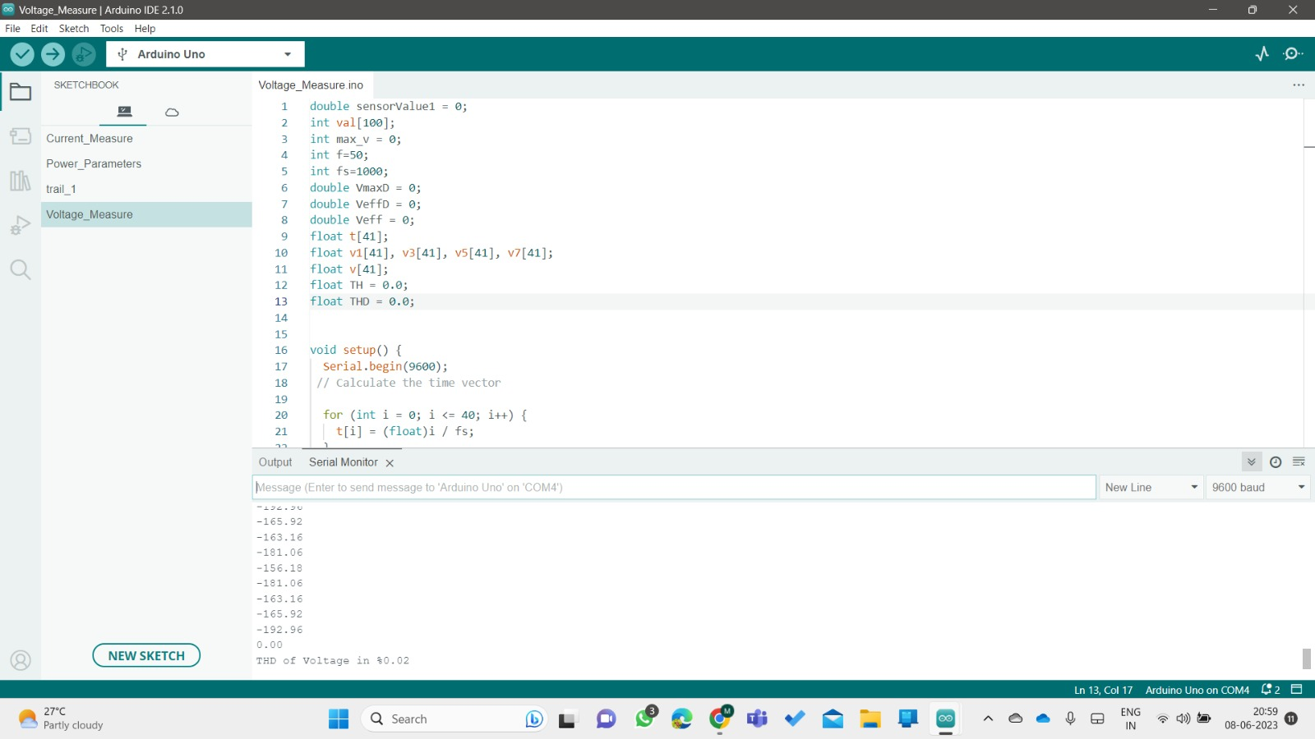

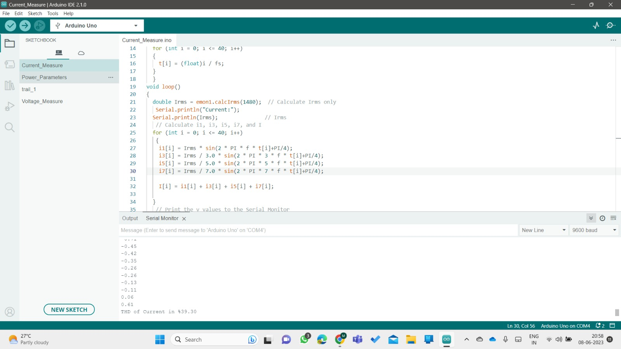

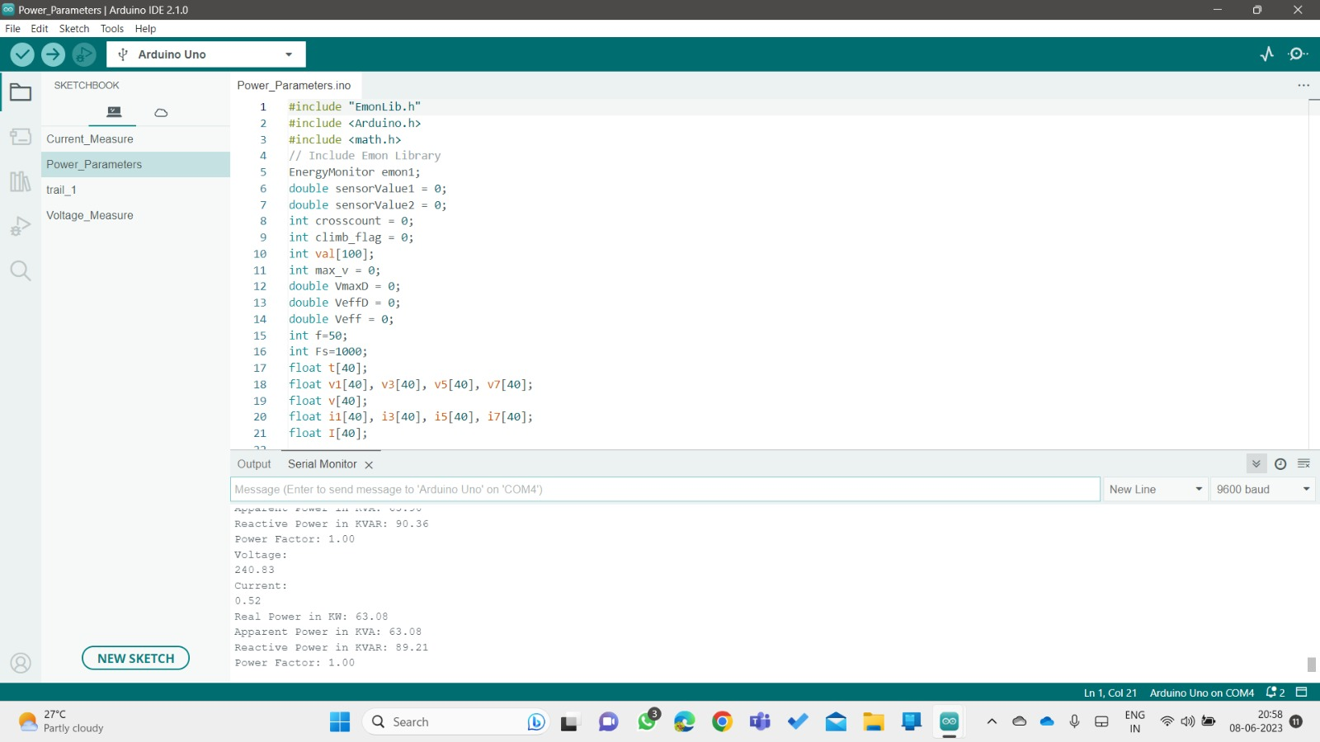

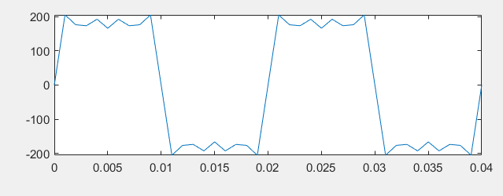

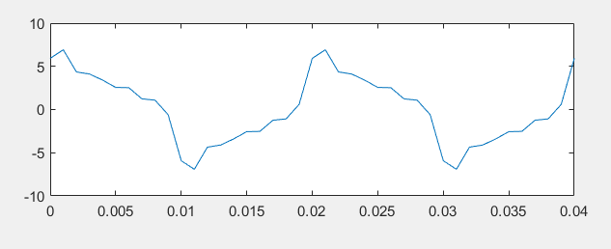

**Result:**

We successfully found the THD% of Current as 39.30% and THD% of voltage as 0.02% and found as waveforms of current and voltage. And found results as follows:

Voltage: 240.83V

Current: 0.52A

Real Power: 55.51W

Apparent Power: 63.08KVA

Reactive power: 89.21 KVAR

Power Factor: 0.88

**Inference:**

We connected the circuit, for the given ac supply we connected voltage sensor parallel to it and current sensor in series to the supply. And we connected a burden network for secondary side of current sensor which act as a transformer. We used here a linear load like mobile charger and a bulb of 100W. actually we should use a non-linear load in order observe the distortion in current waveform. By using a linear load, we manually given distortion in order to observe the changes we include a phase shift difference to the current waveform function when compared to voltage waveform function. From the above-mentioned arrangement we can conclude that when a distortion in included then power factor decreases, then THD% is increases which shows that power reaching to the load applied is decreases. This we can observe in power parameter values which we obtained.